Add Microsoft Teams to Your Blackboard Course and Create Your First Meeting

Please note that the Microsoft Teams meeting integration for Blackboard does not create a Microsoft Team for your class to facilitate file sharing and the collaborative use of other Microsoft tools. Creating meetings with the integration does not work in Safari. Instructors must use Edge, Chrome, or Firefox, to create and launch sessions. Session recordings are not accessible to students or instructors in Blackboard and must be manually added to your course from OneDrive.

1. Using Chrome, Firefox, or Edge, navigate to [Blackboard](https://bb.cod.edu/) and open the course that will be used with Microsoft Teams.
2. Ensure that Edit Mode is set to **“ON”.**
3. Click the **plus +** icon at the top of the Course Menu and select **“Content Area”**.
4. Type **“Microsoft Teams”** in the Title field.
5. Tick the checkbox to ensure this area is available to students.
6. Use the reordering arrows or the drag-and-drop feature to move the “Microsoft Teams” Content Area to the first position in your Course Menu.
7. Select the **“Microsoft Teams”** Content Area to open it.
8. Select the **“Tools”** menu, expand “**More Tools”,** and choose “**Microsoft Teams”.**
9. On the “Create Link: Microsoft Teams” screen, select “**Submit**” to add the Microsoft Teams scheduler to your course.
10. Select the Microsoft Teams link you added to the content area.
11. Select the **“Sign in”** button. You may need to scroll down the page to access the button.
12. **Sign in** to Microsoft Teams using your College of DuPage email credentials. (Note: if you are off campus, you will need complete the sign in process using Duo multifactor authentication.)
13. Select the **“Create meeting link”** button. You may need to scroll down the page to access the button.  
    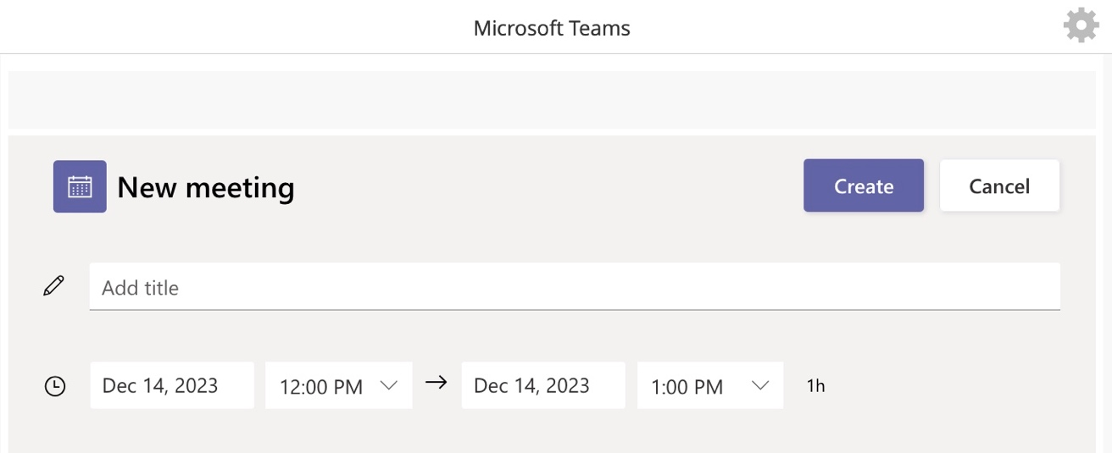
14. Type a ***Title*** for your meeting.
15. Choose the ***Date*** for your meeting and select the **start and end time**.
16. Select **“Create”** to create your meeting.
17. Additional options for your meeting can be configured by selecting “**Meeting options”.**
18. To add the meeting as an event to your course Calendar, select the **“Add to Calendar”** button. A link for students to access the session has been added to the top of the “Microsoft Teams” Content Area.
19. Repeat steps 10 through 18 for each meeting you would like to schedule for your course.

# Additional Resources and Support

* To learn more about the effective use of Microsoft Teams, access the [**Teams Meeting Training site**](https://support.microsoft.com/en-us/office/tips-for-teams-meetings-23dd847d-52a6-4325-b0dd-9d8f2b29af50).
* For faculty and staff support for Teams, contact the IT Help Desk at [**helpdesk@cod.edu**](mailto:helpdesk@cod.edu) or **(630) 942-4357**. Students should contact the **Student Help Desk** at [**studenthelp@dupage.edu**](mailto:studenthelp@dupage.edu)or (**630) 942-2999** for support.
* For faculty support in utilizing the Teams integration in Blackboard, contact Learning Technologies at [**learningtech@cod.edu**](mailto:learningtech@cod.edu)or (**630) 942-2490**.