Add Zoom to Your Blackboard Course and Create Your First Meeting

Before proceeding, you must have a Zoom account login for your @cod.edu email address. Ensure that you are logged into Zoom using this account or you will not be able to successfully launch sessions from Blackboard. For assistance with your Zoom account or to request that your account is upgraded from the Basic license to remove the 40-minute meeting limit, please contact the IT Help Desk at[**helpdesk@cod.edu**](mailto:helpdesk@cod.edu) or **(630) 942-4357**.

1. Using Chrome, Firefox, or Edge, navigate to [Blackboard](https://bb.cod.edu/) and open the course you want to use Zoom with.
2. Ensure that Edit Mode is set to **“ON”.**
3. Click the **plus +** icon at the top of the Course Menu and select **“Tool Link”**. Then choose **“Zoom”.**
4. Type **“Zoom”** into the *Title* field and tick the checkbox to ensure that the link will be visible to students. Select **“Submit”**.
5. The Zoom tool has been added to your course menu. Use the reordering arrows or drag-and-drop to position it higher on the menu for students.
6. To schedule your first meeting or meeting series, select the **Zoom** *Tool Link*.
7. Select **“Schedule a New Meeting”** and add a descriptive *Title*, choose the start date and time, and meeting duration. To establish a regular schedule of recurring meetings, tick the **“Recurring meeting”** check box.  
   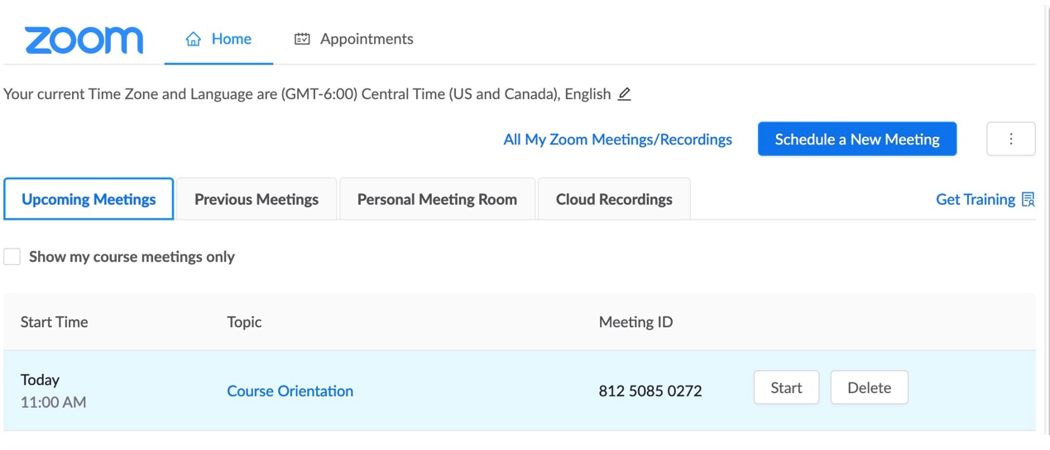
8. Review the other session and security configuration options and make any additional customizations. Select **“Save”** to create your meeting or series.
9. When students click the **Zoom** *Tool Link*, they will have access to session links and recordings all in one place.

# Additional Resources and Support

* To learn more about how to effectively use Zoom, access the [**Zoom Learning Center**](https://support.zoom.com/hc/en/article?id=zm_kb&sysparm_article=KB0060166).
* For faculty and staff support for Zoom, contact the IT Help Desk at [**helpdesk@cod.edu**](mailto:helpdesk@cod.edu) or **(630) 942-4357**. Students should contact the **Student Help Desk** at [**studenthelp@dupage.edu**](mailto:studenthelp@dupage.edu)or (**630) 942-2999** for support.
* For faculty support for utilizing the Zoom integration in Blackboard, contact Learning Technologies at [**learningtech@cod.edu**](mailto:learningtech@cod.edu)or (**630) 942-2490**.